**IMAX Screen Cleaner**

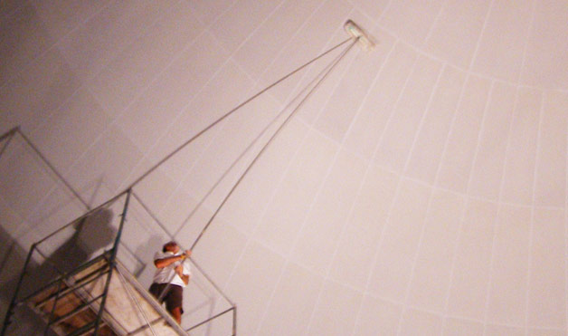

The magnificent, larger-than-life images on IMAX screens wouldn’t be quite as powerful if they were cloaked in a layer of dirt and dust. Luckily, there are companies dedicated to keeping your viewing experience crystal clear. According to Michael Quaranto, cofounder of IMAX screen cleaning company 1570 Cinema Services, the biggest challenge to keeping the screens clean is making sure they’re dust-free (they are so dusty, cleaners usually have to empty their vacuum two or three times per screen). Photo courtesy of[*1570 Cinema Services*](http://www.1570cinemaservices.com/).

**Professional Whistler**



Believe it or not, you can make a living off whistling while you work. Just ask Henry Brady, a 58-year-old Welsh whistling performer. “A whistler is an artist just like an actor or musician,” he told FOX News. “My profession has taken me across the world and allowed me to touch people’s hearts.” To be a professional whistler, not only do you need talent, Brady also stresses the importance of self-promotion. Photo by Shutterstock.

**Wrinkle Chaser**



When you slip your feet into a brand-new pair of shoes, take a moment to admire their smooth, wrinkle-free design. Why? Because someone spent a lot of time making sure your footwear is crease-free. At shoe companies, it’s a wrinkle chaser’s job to use a special iron to ensure shoes are smooth as glass when they leave the factory. Photo by Shutterstock.

**Furniture Tester**



If anyone’s ever called you a couch potato before, he may have inadvertently been giving you career advice. Loungers actually get paid to test furniture for companies by sitting on it. Well, sitting and moving. They have to wriggle around, rock, lean back, lean forward and assess the overall level of comfort. Some positions even require furniture testers to try out 200 different pieces in a single day. So they can’t get too comfortable. Photo by Shutterstock.

**Pet Food Taster**

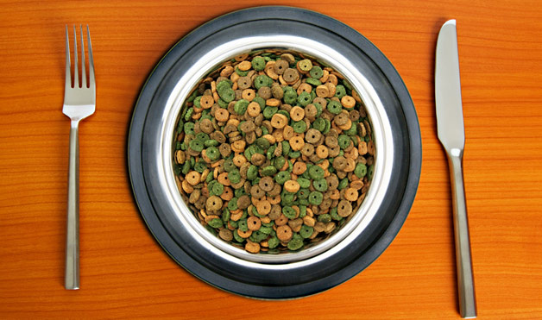

If pets could talk, people wouldn’t have to taste-test cat and dog food. To make sure the flavors are just right, a group of adventurous eaters chow down on pet food, remarking on everything from texture to tartness. But they only go so far: Simon Allison, a senior food technologist for Marks & Spencer, admits to spitting out the pet food after tasting it and keeping a glass of water on hand to rinse with. Photo by Shutterstock.

**Golf Ball Diver**

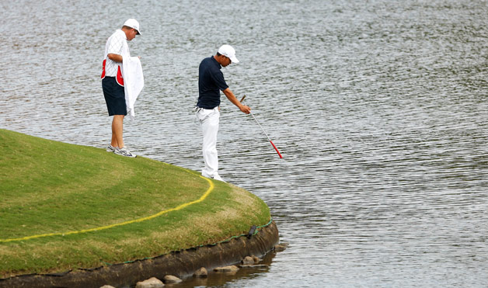

When golf balls are accidentally pitched into a course’s water hazards, they’re usually considered goners. But to people who salvage sunken golf balls for a living, those deep-sixed balls have dollar signs on them. There’s a whole industry devoted to rescuing submerged golf balls and selling them “used” to golf courses. The golf courses like the discounted goods and SCUBA enthusiasts can rake in the dough—sometimes six figures, depending on where they’re based. Photo by Getty Images.

**Fake Review Writer**



Definitely unethical, but unfortunately some people make cash by writing fake reviews of businesses for companies that post on consumer-driven sites like Yelp, Citysearch and Urbanspoon. Their false enthusiasm for hotels, restaurants and products is meant to artificially boost ratings and slam the competition. Photo by Shutterstock.

## Golf Ball Diver

**Quick Stats**

Salary Range

$32,000 – $90,000

Data from U.S. Department of Labor

**What do Golf Ball Divers do?**

Golf courses are designed to be both beautiful and punishing. Water features can catch the shimmer of the sunlight, but they can also swallow up golf balls. Golf Ball Divers scoop up these misdirected balls so they can be cleaned and sold to other self-punishing [**Golfers**](http://www.insidejobs.com/careers/golfer).

Golfers may not like to see Golf Ball Divers at work. That’s because as a Golf Ball Diver, you’re a reminder of their failures. So most of the time, you do your work very early in the morning, before the Golfers arrive. Having the course to yourself is one big perk of the job.

When you arrive, you strap on scuba gear and dive to the bottom of the water feature. It’s likely that you won’t be able to see the bottom, as it’s probably covered with algae and plants, so you feel for golf balls with your hands. When you find a golf ball, you drop it in a collection bag.

The work is physically demanding. While one single golf ball may be quite light, 100 golf balls are definitely very heavy. Hauling these big loads from the bottom of a lake requires big muscles.

When you’re done scouting the water feature for errant balls, you package them all up and give them to your employer. You keep an accurate count of all of the balls you collect, and provide that paperwork to your employer as well.

**Should I be a Golf Ball Diver?**

You should have a certificate degree or higher and share these traits:

• **Calm Under Pressure:** You keep your cool when dealing with highly stressful situations.

• **Levelheaded:** You hold your emotions in check, even in tough situations.

• **Ready for a Challenge:** You jump into new projects with initiative and drive.

## You’re a what? Golf ball diver

*Dennis Vilorio* | *June 2014*

At golf courses throughout the country, little round treasures lurk underwater. Although they got there accidentally, their location is no secret. But to cash in, someone like Scott Evans needs to get them out.

Scott is a golf ball diver, specializing in finding submerged golf balls in Jacksonville, Florida. During golfers’ rounds of play, the balls roll or are hit into water hazards (small ponds that are scattered throughout a golf course). Golf balls are waterproof, so they don’t get damaged underwater. Salvaging and recycling them offers golfers a less expensive alternative to buying new.

### What they do

Golf ball divers are professional recyclers: They retrieve golf balls, which are then cleaned, repackaged, and resold. Before beginning work at a golf course, they meet formally with its owner or manager to agree on the terms of the job. For example, the course charges the diver a fee for the opportunity to harvest the ponds. The course representative and the diver need to negotiate the price—and discuss whether that fee will be paid with money, in recovered golf balls, or a combination of both.

A typical golf course has between 4 and 12 ponds. Divers spend 8 to 10 hours per day harvesting the ponds and may need multiple days to finish a job. Depending on the size of each pond, divers recover balls with the help of a dive crew or a roller. Using a roller is faster than a dive crew, but dive crews are more thorough.

**Dive crew.** A dive crew usually includes three people. Equipped with standard scuba gear, two divers enter a pond and feel for the balls by hand. “The water is so black and murky that you have to dive by feel,” says Scott. The divers then load the balls into baskets and pass them to the remaining crewmember on land. This crewmember also ensures the divers’ safety and helps direct them so they can comb the entire pond.

**Roller.** Two-person dive crews may work with a roller, which consists of metal discs on wheels. The roller’s metal grooves grasp balls as it moves through the water. Crewmembers stand on the ground at opposite ends of the pond and guide the roller by pulling on a wire connected to it.

If the roller gets stuck in mud or rocks, one of the crewmembers goes underwater to free it. After they have combed the pond, crewmembers pull the roller to the ground and pop out the golf balls.

Rollers are limited by the size of the pond: Some ponds are too large to accommodate a roller.

### What it’s like

Diving for golf balls may sound more like play than work. But there are several factors that aspiring divers should consider. For example, finding steady work may be difficult.

**Work environment.** Golf ball divers generally work in adverse conditions in the pond. “You must be comfortable working where you can’t see,” Scott says. “I’ve seen a lot of divers who couldn’t handle the low visibility.”

Golf ball divers work in crews for safety reasons. They may face danger from wildlife, such as alligators, and from objects hidden underwater. And scuba equipment is heavy, so obstacles such as a fishing line could trap and drown divers.

The tasks are also physically demanding, repetitive, and tiring. For example, divers are often on their knees in mud when searching for balls.

A diver's work schedule depends on golf course events. Divers may have to work when the course has nothing else scheduled, so they must be available any day of the week.

**Employment and wages.** The U.S. Bureau of Labor Statistics (BLS) does not collect employment and wage data specifically on golf ball divers. Instead, BLS groups them with commercial divers.

Typically, golf ball divers earn money for each ball they recover. Buyers include the golf course, retailers, and golf ball companies. Anecdotal information suggests that divers earn about $200 a day. But, as independent contractors, divers must account for taxes and benefits (such as insurance, paid leave, and retirement savings) from that amount.

Golf ball divers commonly work part time and have another job. “The work and income are not stable,” says Scott, “so you may end up doing something like cleaning boats or inspecting bridges in between diving jobs.” Divers sometimes arrange for multiple diving jobs in different cities to allow for more favorable conditions year round.

### How they prepare

Golf ball divers must be at least 18 years old and be certified for unrestricted commercial scuba diving. Certification may require up to 200 hours of dive experience, including low visibility diving, underwater navigation, and search and recovery.

Divers may become certified through an accredited scuba diving program or on-the-job training. Aspiring divers who join an accredited program usually attend full time for 7 to 9 months. Another option is a certification course, which typically lasts 4 to 6 weeks. Apprentices start as part of the ground crew; later, they move on to golf ball recovery.

For safety reasons, divers must be certified in first aid and dive rescue. They also must get a doctor’s approval for sound physical health and be able to lift up to 60 pounds so they can move the roller and scuba equipment on the ground.

### Why they dive

Golf ball divers enjoy working outside. Because golf courses are generally well maintained, the manicured landscapes are attractive and designed for comfortable walking. But the conditions that draw golfers to the course are often the ones that challenge divers. “What makes the work good is also what makes it bad,” says Scott. “The days when you’re out working in the cold or heat are excruciating.”

What appeals most to Scott about his work is preserving the environment. “I feel good about cleaning the environment and recycling the balls,” he says. “If you’re willing to work hard, this is a good place to be.”